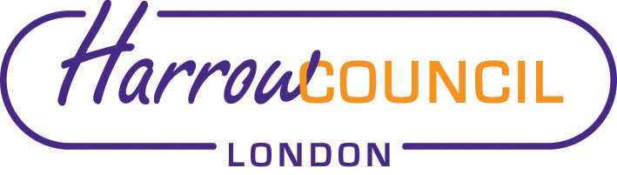
Harrow ASC and SACRE Meeting

Tuesday 6 December 2022 at 7.30 p.m.

Enquiries & apologies to:
Vivian Wright, Clerk to SACRE
vmwright@waitrose.com

Adviser to SACRE: Lesley Prior

Venue: Harrow Council Hub. Forward Drive, Harrow, HA3 8PG.

Click link below for a map. .

https://www.google.com/maps/place/Forward+Dr,+Harrow+HA3+8NT/@51.590084,-0.3293268,17z/data=!3m1!4b1!4m5!3m4!1s0x4876138305ee3cef:0xa119f0142434b617!8m2!3d51.5904851!4d-0.3268002

Location details - Auditorium, Harrow Council Hub – Harrow Council

Agenda

- Welcome:

- Election Vice-Chair (held over from previous meeting)

- Apologies for absence:

- Minutes of the last meeting on 20 September 2022 (attached): to agree the minutes as a true record.

- Matters arising from the minutes

- ASC update

- NASCRE new website

- Shared space: https://nasacre.org.uk/shared-space/
- Training programme: https://nasacre.org.uk/training-and-support/presentations-recordings/

- 2021 Census data on religion

- Annual report

- Local and National updates

- News from Faith Groups relating to schools

- Any Other Business

- Future Dates
- Wed 1 March 2023

